**SCHNEEBERGER GmbH**  May 2024

**LINEAR TECHNOLOGY**

Grafenau 12

D-75339 Hoefen / Enz

Deutschland

Phone +49 (0)7081 / 782- 0

Fax +49 (0)7081 / 782-147

E-mail info-d@schneeberger.com

Internet [http://www. schneeberger.com](http://www.schneeberger.com/)

Contact:

Peter Schoenbach

Vice President

[peter.schoenbach@schneeberger.com](mailto:peter.schoenbach@schneeberger.com)

**GrindingHub 2024**

**SCHNEEBERGER „Ball Screws SBS“**

**Ball screws for demanding applications**

The new SCHNEEBERGER ball screws (SBS) impress with their precision and performance, to which the ground and hardened ball contact surfaces contribute in particular. Thus, the SBS ball screws are equally suitable for use at high and low speeds as well as oscillating short-stroke movements. This makes them particularly interesting for demanding applications in machine tools, as well as measuring and testing technology.

With the new SBS ball screws, SCHNEEBERGER complements its extensive linear technology portfolio. Always in focus: optimum precision and cost-effectiveness. To ensure these properties in the long term, the ball tracks, bearing seats and contact surfaces of the ball screws are precision ground. The outer diameter of the spindle, which is ground in the same clamping with bearing seats, even combines a double advantage. On the one hand, the ball screw can be aligned with the spindle outer diameter, and on the other hand, the performance of the wiper systems is significantly increased. The induction-hardened spindle and through-hardened nut are equally important.

In sum, the precise and hard ball contact surfaces enable optimum power transmission with extremely high positioning and repeat accuracies. In addition, ball screws from SCHNEEBERGER are characterized by smooth, constant torque running behavior. Equally important is the associated low heat generation, minimal wear and long service life.

All these properties set new standards for applications in demanding industries. These include machine tool manufacturing, measuring and testing technology, drive and process engineering, as well as robotics and automation. Depending on requirements, the SBS is available with spindle diameters of 32 mm, 40 mm, 50 mm and 63 mm. The thread length is 2,000 mm, the convertible accelerations are 1,5g and the maximum speeds are 100 m/min. The accuracy class according to ISO - type P is IT3. Application technicians and engineers from SCHNEEBERGER are ready to assist in the calculation and design of customer projects.

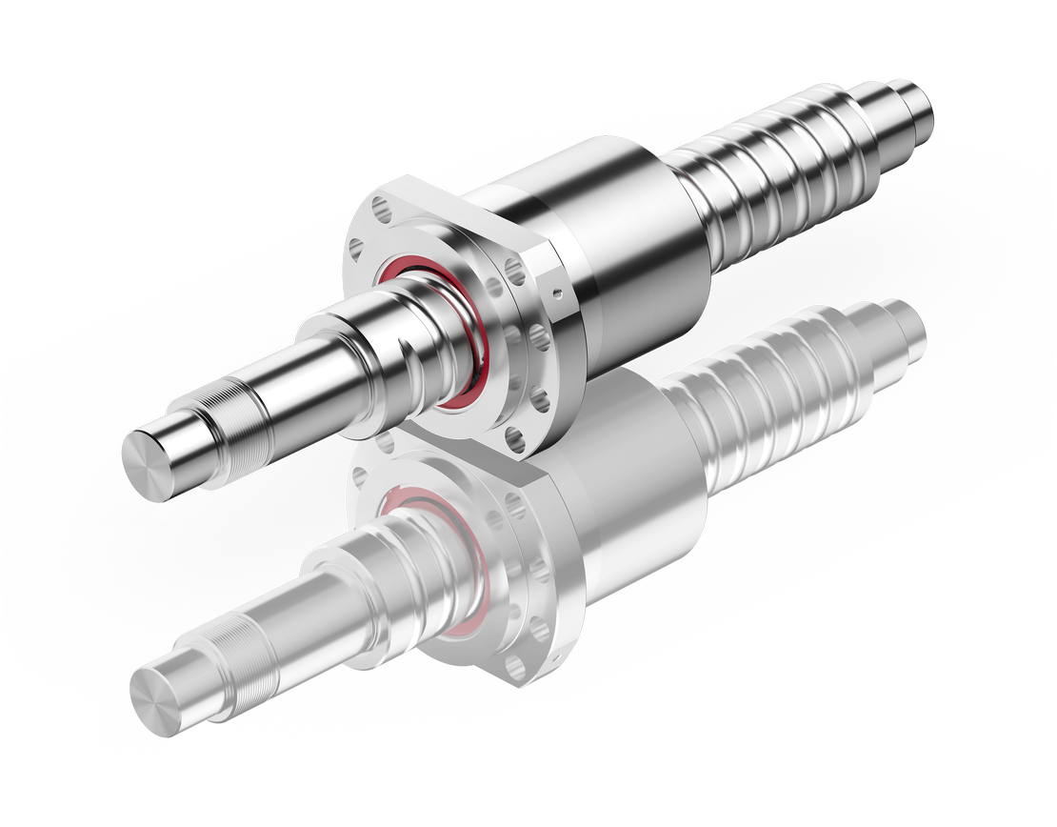

**Fig.: SCHNEEBERGER Ball Screws SBS**